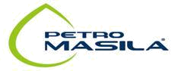
MASILA PETROLEUM EXPLORATION AND PRODUCTION CO.
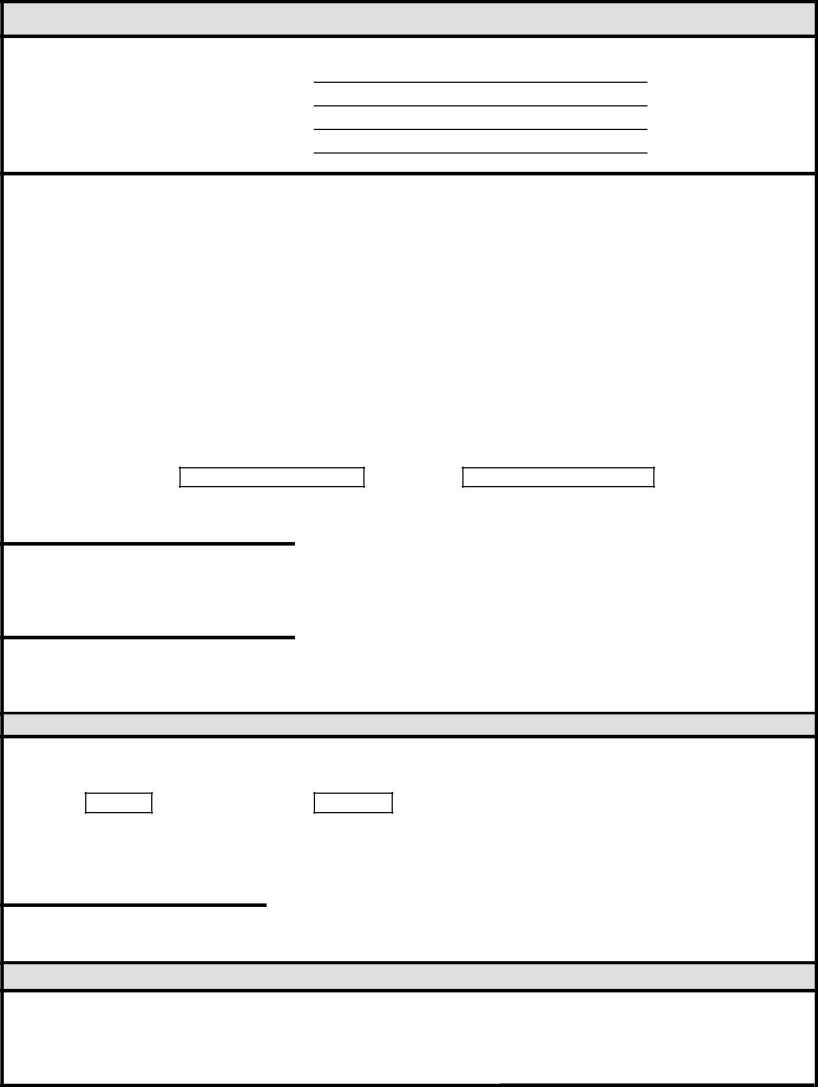

Hajj LEAVE REQUEST

Employee Name:

EY#:

Department:

Date:

Policy Guidelines

Petro Masila's policy states that every employee with 4 years service is eligible to 20 days paid holiday for Hajj. Such leave can only be utilized once in a lifetime, either with the Company or when they can provide written proof from previous employers. In the case of rotational positions, employees on Hajj are not considered to be working and do not earn additional leave days for the days taken off for Hajj. In other words, Hajj leave for rotational employees is 3 weeks after which the employee has to resume his normal 1:1 work rotation. For instance, if the employee worked 4 weeks then he will earn 4 weeks off plus three weeks as Hajj leave, which is 7 weeks leave in total. Buy out of Hajj leave will not be considered if Hajj leave has not been fully used. To make sure that the holiday has been used for Hajj purposes, the employee must provide HR with the following:

- Air ticket stubs and the issued Hajj passport or visa.

- Pre and post rotation of Hajj leave.

I understand and adhere to the above policy. Hereby, I request you to grant me Hajj leave.

from:

To:

Employee Signature

Department Manager/Supt. Approval

HR Approval

Has the employee provided the required documents?

YES:

NO:

Years of Service:______________

Hajj Entitlements:______________

HR SPECIALIST Approval

Comments:

C:\Users\al-kayab\Downloads\Hajj Leave (2).doc

